Trevor McLaurine

6/23/2023

Assignment 5.2 - Web 335

Add New User



Update Mozart Email

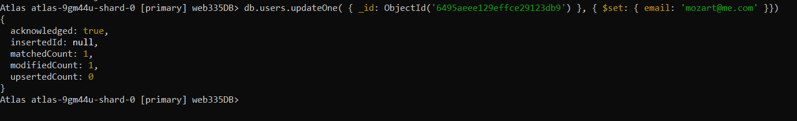

Using $Project

